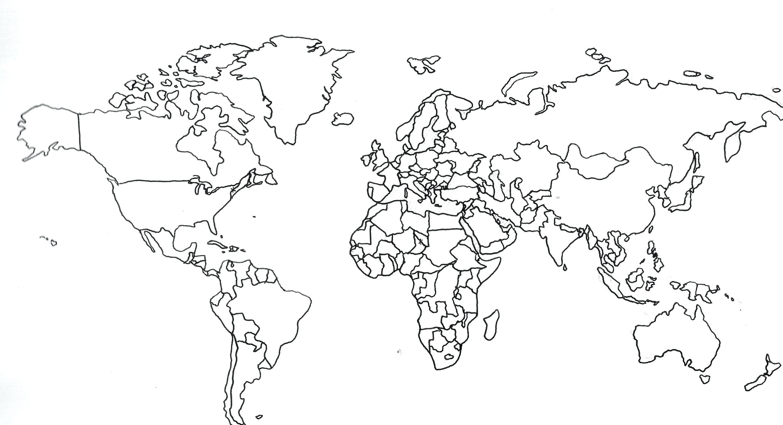
classification of countries based on income per capita
upper-middle income ($4126-$12735)

high income ($12736 or more)

low-middle income ($1046-$4125)

low income ($1045 or less)

country income groups

